

# AUGUST- 2023

**Programme : B.E / B. Tech**

**Course Code : CSA1178**

**Course Name** **: OBJECT ORIENTED ANALYSIS AND DESIGN**

**Date : 11-08-2023**

OOAD PRATICAL DAY 4 Marks:20

**EXP 27 : SUPERMARKET MANAGEMENT SYSTEM**

**AIM:** To draw UML diagrams for supermarket managment system.

**USE CASE :**

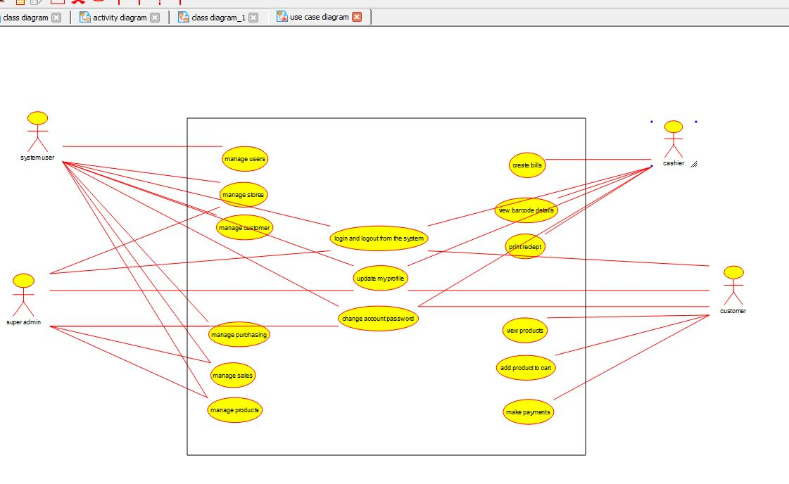

**ACTIVITY :**

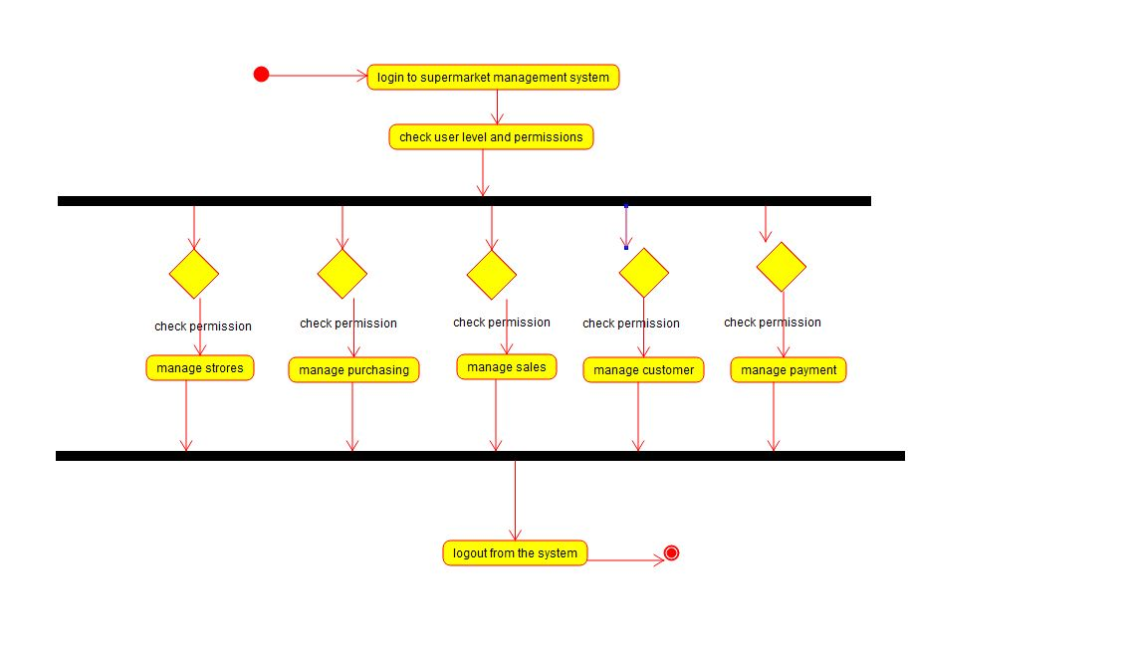

**CLASS DIAGRAM :**

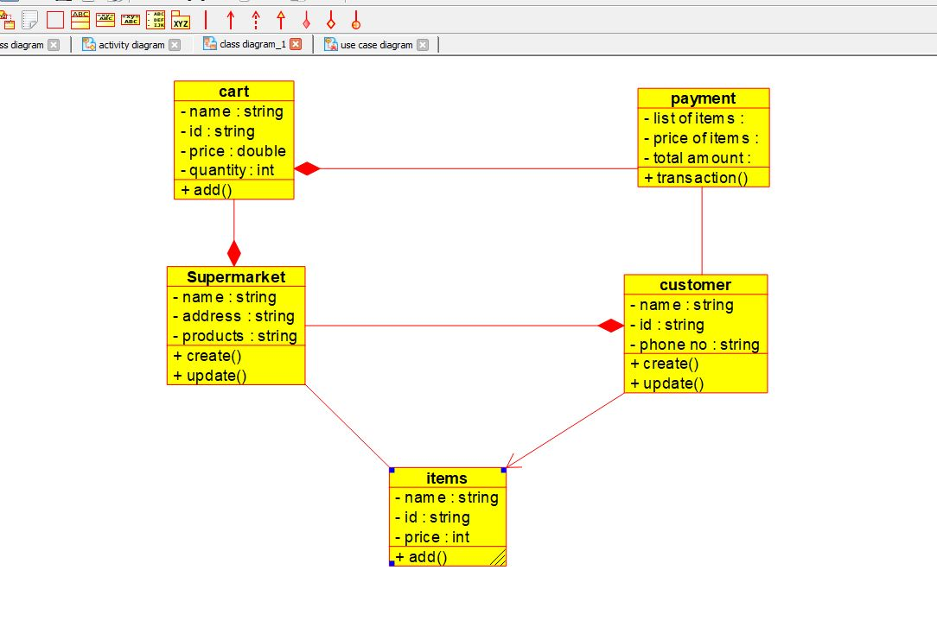

**RESULT** : Program was Executed Successfully using Umbrello**.**

**EXP 28 : AIRLINE RESERVATION SYSTEM**

**AIM :** To draw the UML diagrams for Airline reservation ssystem using umbrello.

**CLASS DIAGRAM:**

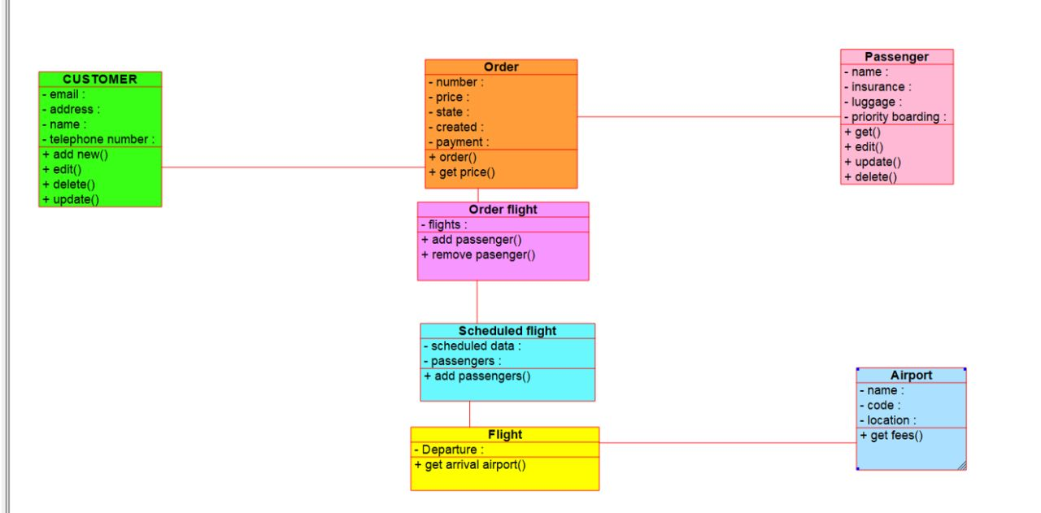

**ACTIVITY :**

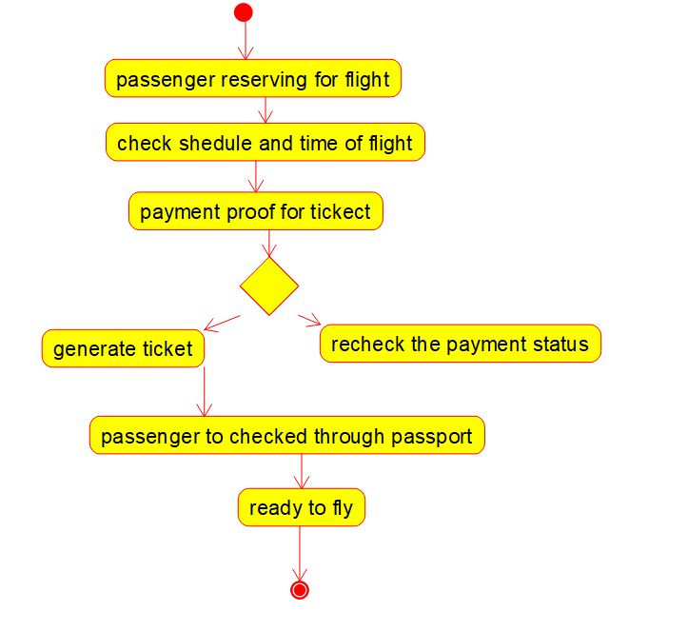

**USE CASE :**

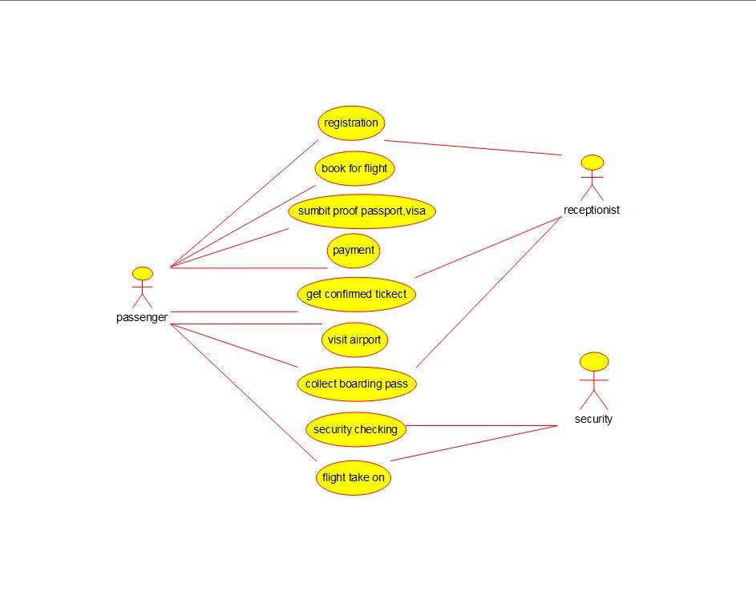

**RESULT** : Program was Executed Successfully using Umbrello**.**

**EXP 29 :**  **BUS TICKET RESERVATION SYSTEM**

**AIM :** To draw the UML diagrams for bus ticket reservation system using umbrello.

**CLASS DIAGRAM:**

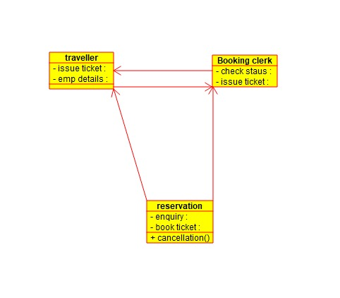

**COMPONENT :**

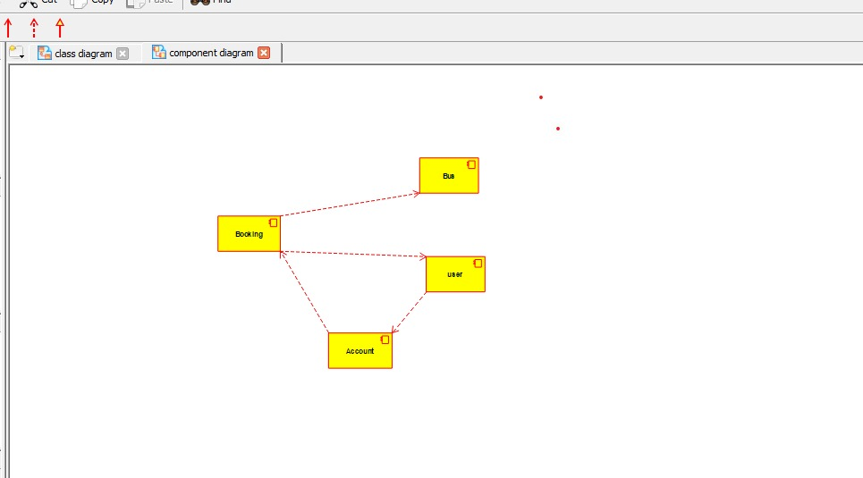

**USE CASE:**

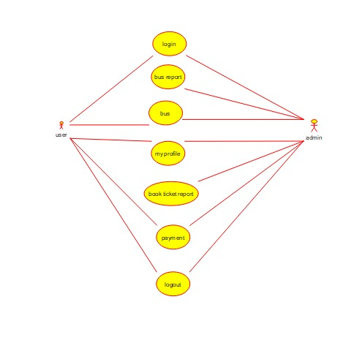

**RESULT** : Program was Executed Successfully using Umbrello**.**

**EXP 30 :** **TRAIN RESERVATION SYSTEM**

**AIM :** To draw UML diagram for train reservation system using umbrello.

**ACTIVITY :**

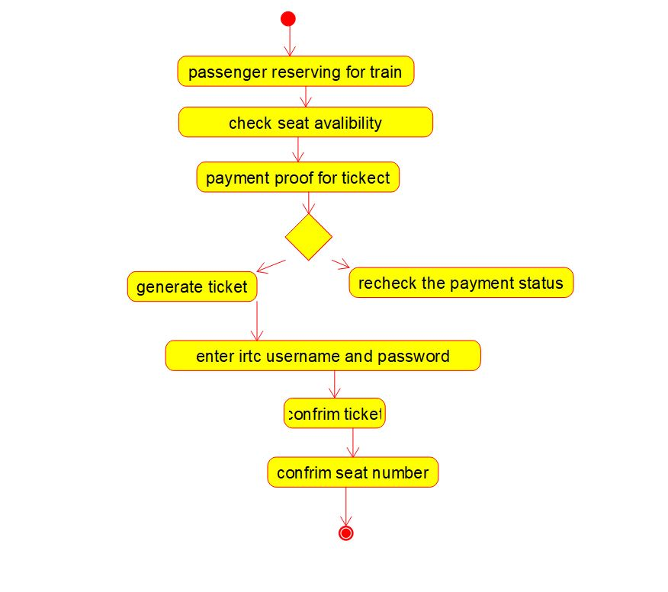

**USE CASE :**

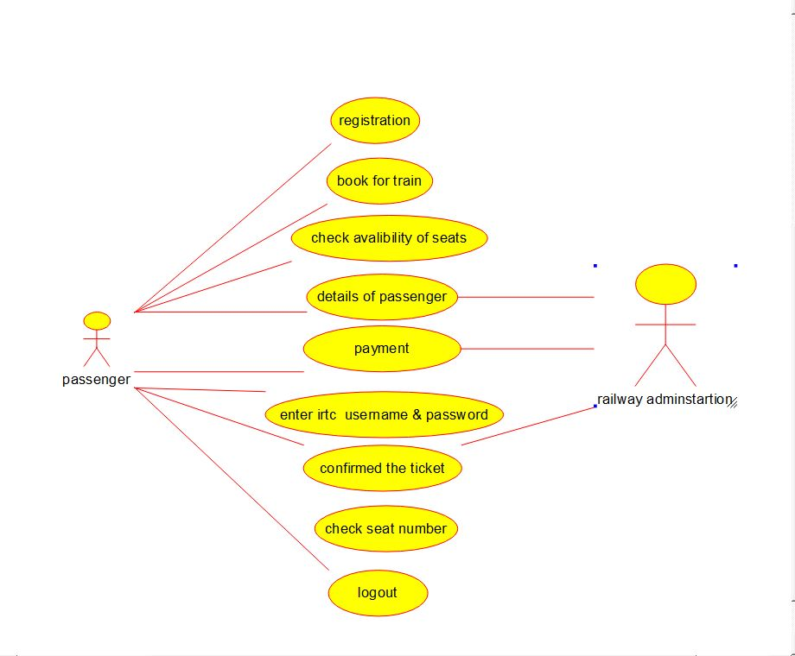

**COMPONENT :**

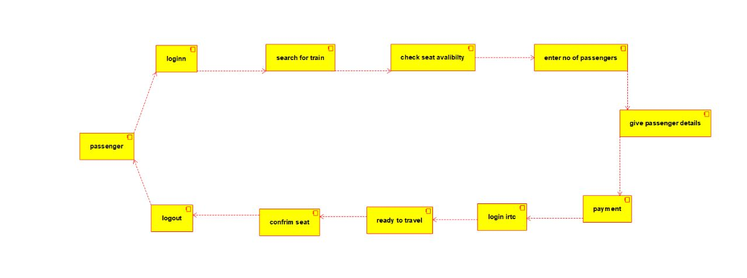

**RESULT** : Program was Executed Successfully using Umbrello**.**

**EXP 31 : AGRICULTURE LOAN MANAGEMENT SYSYTEM**

**AIM** : To draw the uml diagram for agriculture loan management system using umbrello.

**Use case :**

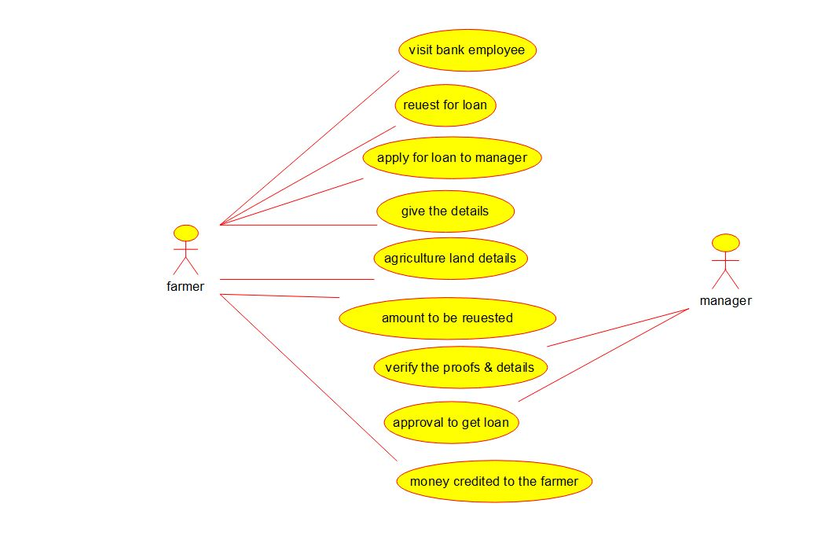

**ACTIVITY :**

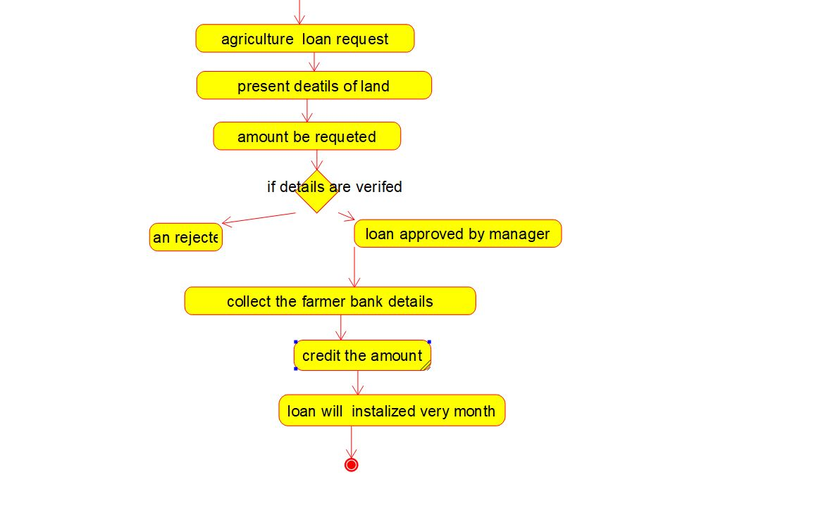

**COMPONENT :**

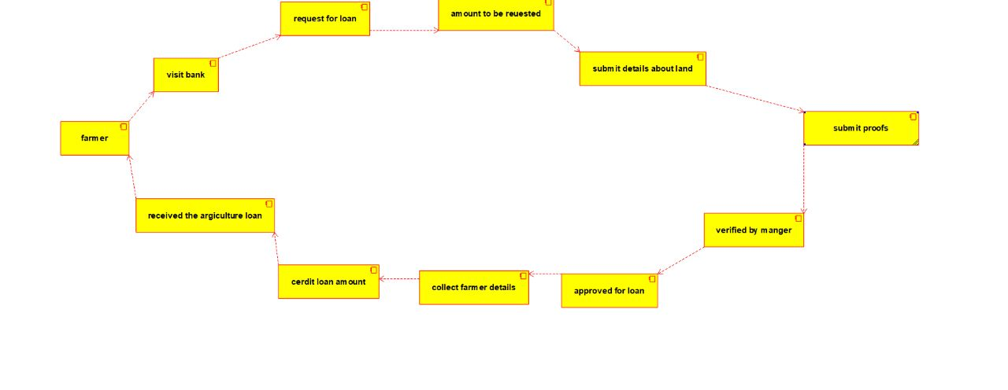

**RESULT** : Program was Executed Successfully using Umbrello**.**

**EXP 32: JEWEL LOAN MANAGMENYT SYSTEM**

**AIM :**  To draw the uml diagram for jewel loan management system using umbrello.

**STATE CHART DIAGRAM :**

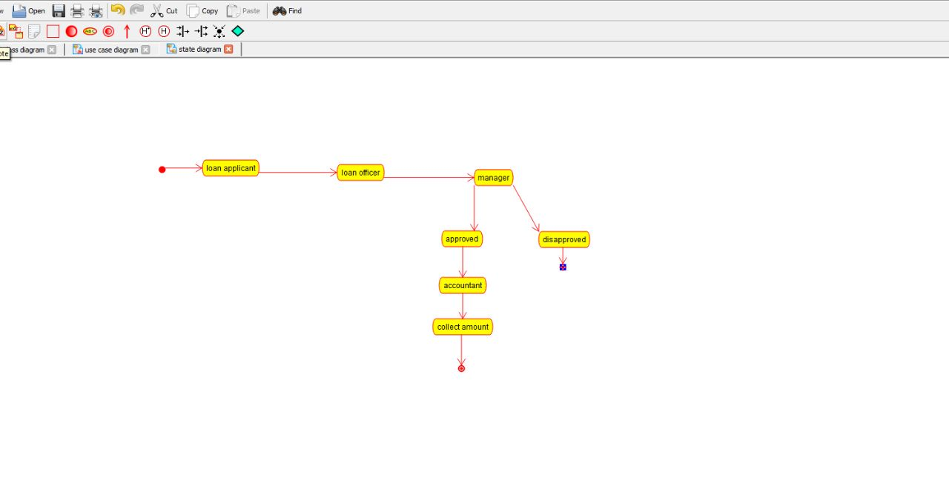

**USE CASE :**

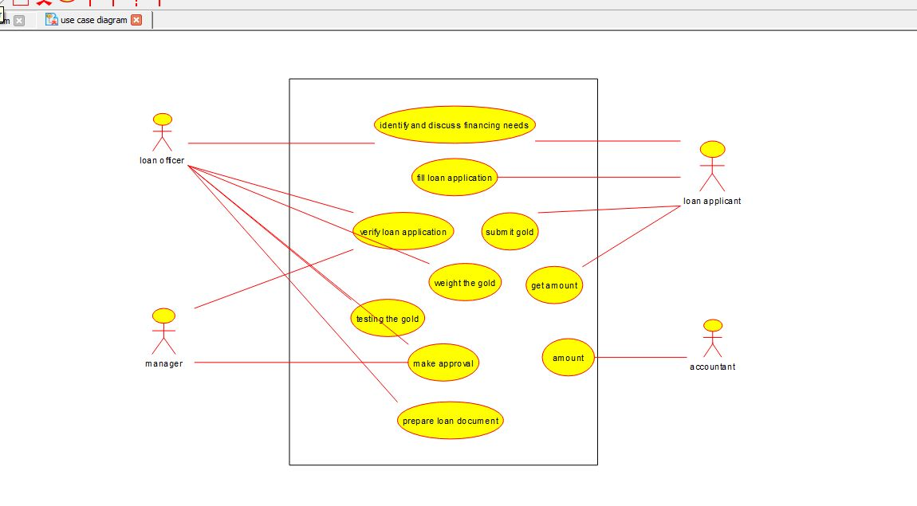

**COLLABRATION :**

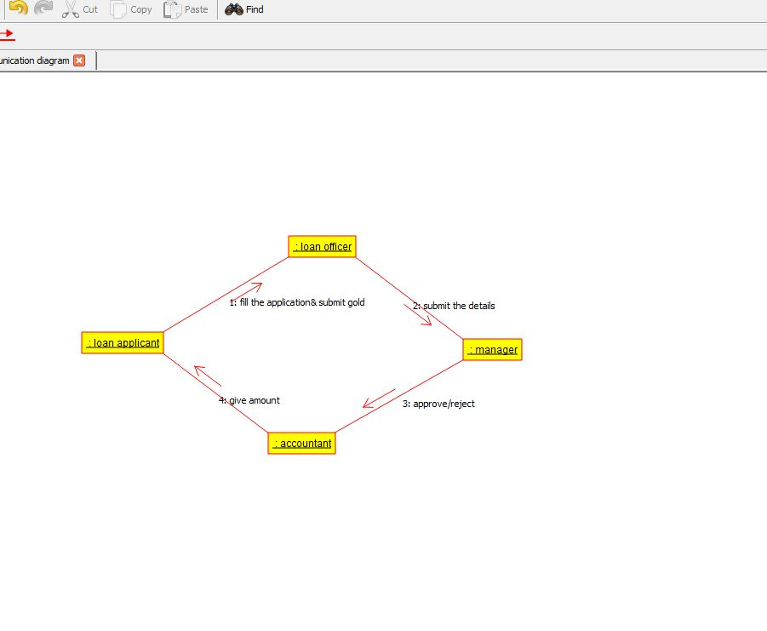

**RESULT** : Program was Executed Successfully using Umbrello**.**